**Visual Analytics**

**Week 4 Lectorial Exercises**

**Exercise 1**



Find an efficient route between Glen Allan in the upper left corner and Cambridge in the lower right. The cognitive process involves a complex set of visual pattern queries. Write them down.

**Exercise 2**



**Map of water currents and temperature.**

Supports reasoning about currents in the Western North Atlantic. The ocean current patterns are represented using streaks of different length and width. The background colour provides information about water temperature.

For each of the following tasks, write down the visual query:

1. Find where the strongest currents are located.
2. Find out where something that was dropped in the water (for example, fish larvae) might end up after a period of time.
3. Find the regions with the coldest water.

**Exercise 3**

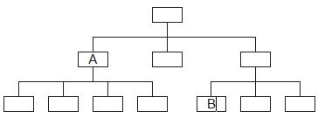

This organisation chart is an example of a link-node diagram.

If A and B should work together on a project, who in the organization should be involved in setting this up? Write down the visual query involved.